Greeting everyone

Thanks again for the opportunity, the instruction to open and run the app are as follow:

Unzip the folder and open it with VC code.

On the terminal type : npm install

After the installation, type npm run build

After the building finished , type npm start .

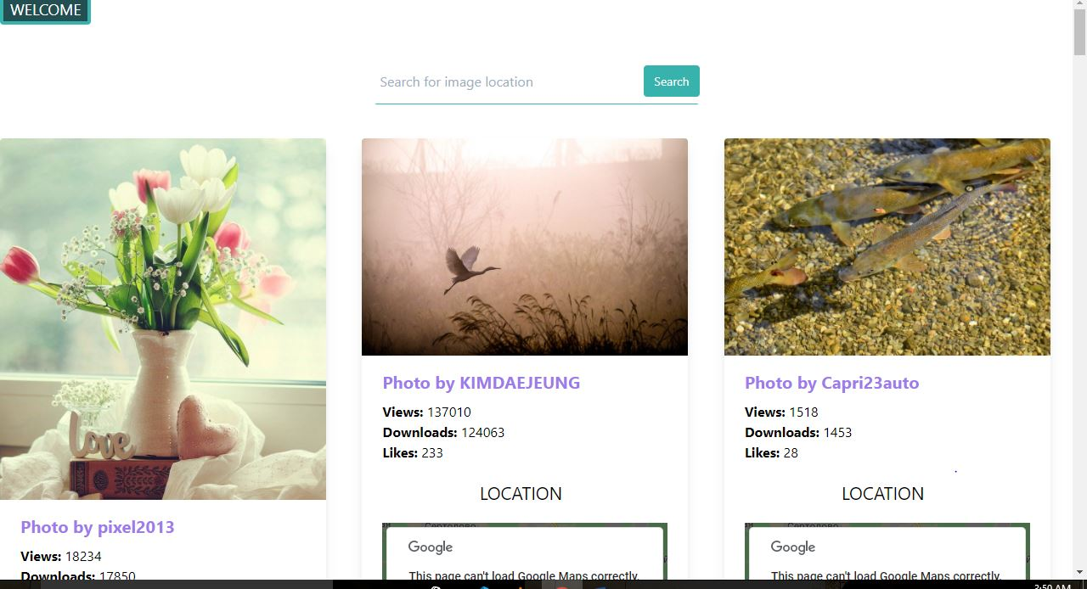

A page that looks like this will be opened with a Google map attached to it. For this first presentation, I used the website called : <https://pixabay.com> to fetch my data because foursquare and other websites were giving me some serious problem.

On the search bar, you can type any location for example Cape town. It will display related pictures to that specific location.

I will be working on future update of the app, great design and colors.